COMM 156
Media and the Visual Representation of Conflict, Violence and War*
Spring, 2023 (Tuesdays / Thursdays 5:00 – 6:20) HSS 1315

Gary Fields gfields@ucsd.edu
Office Hours: By Appointment

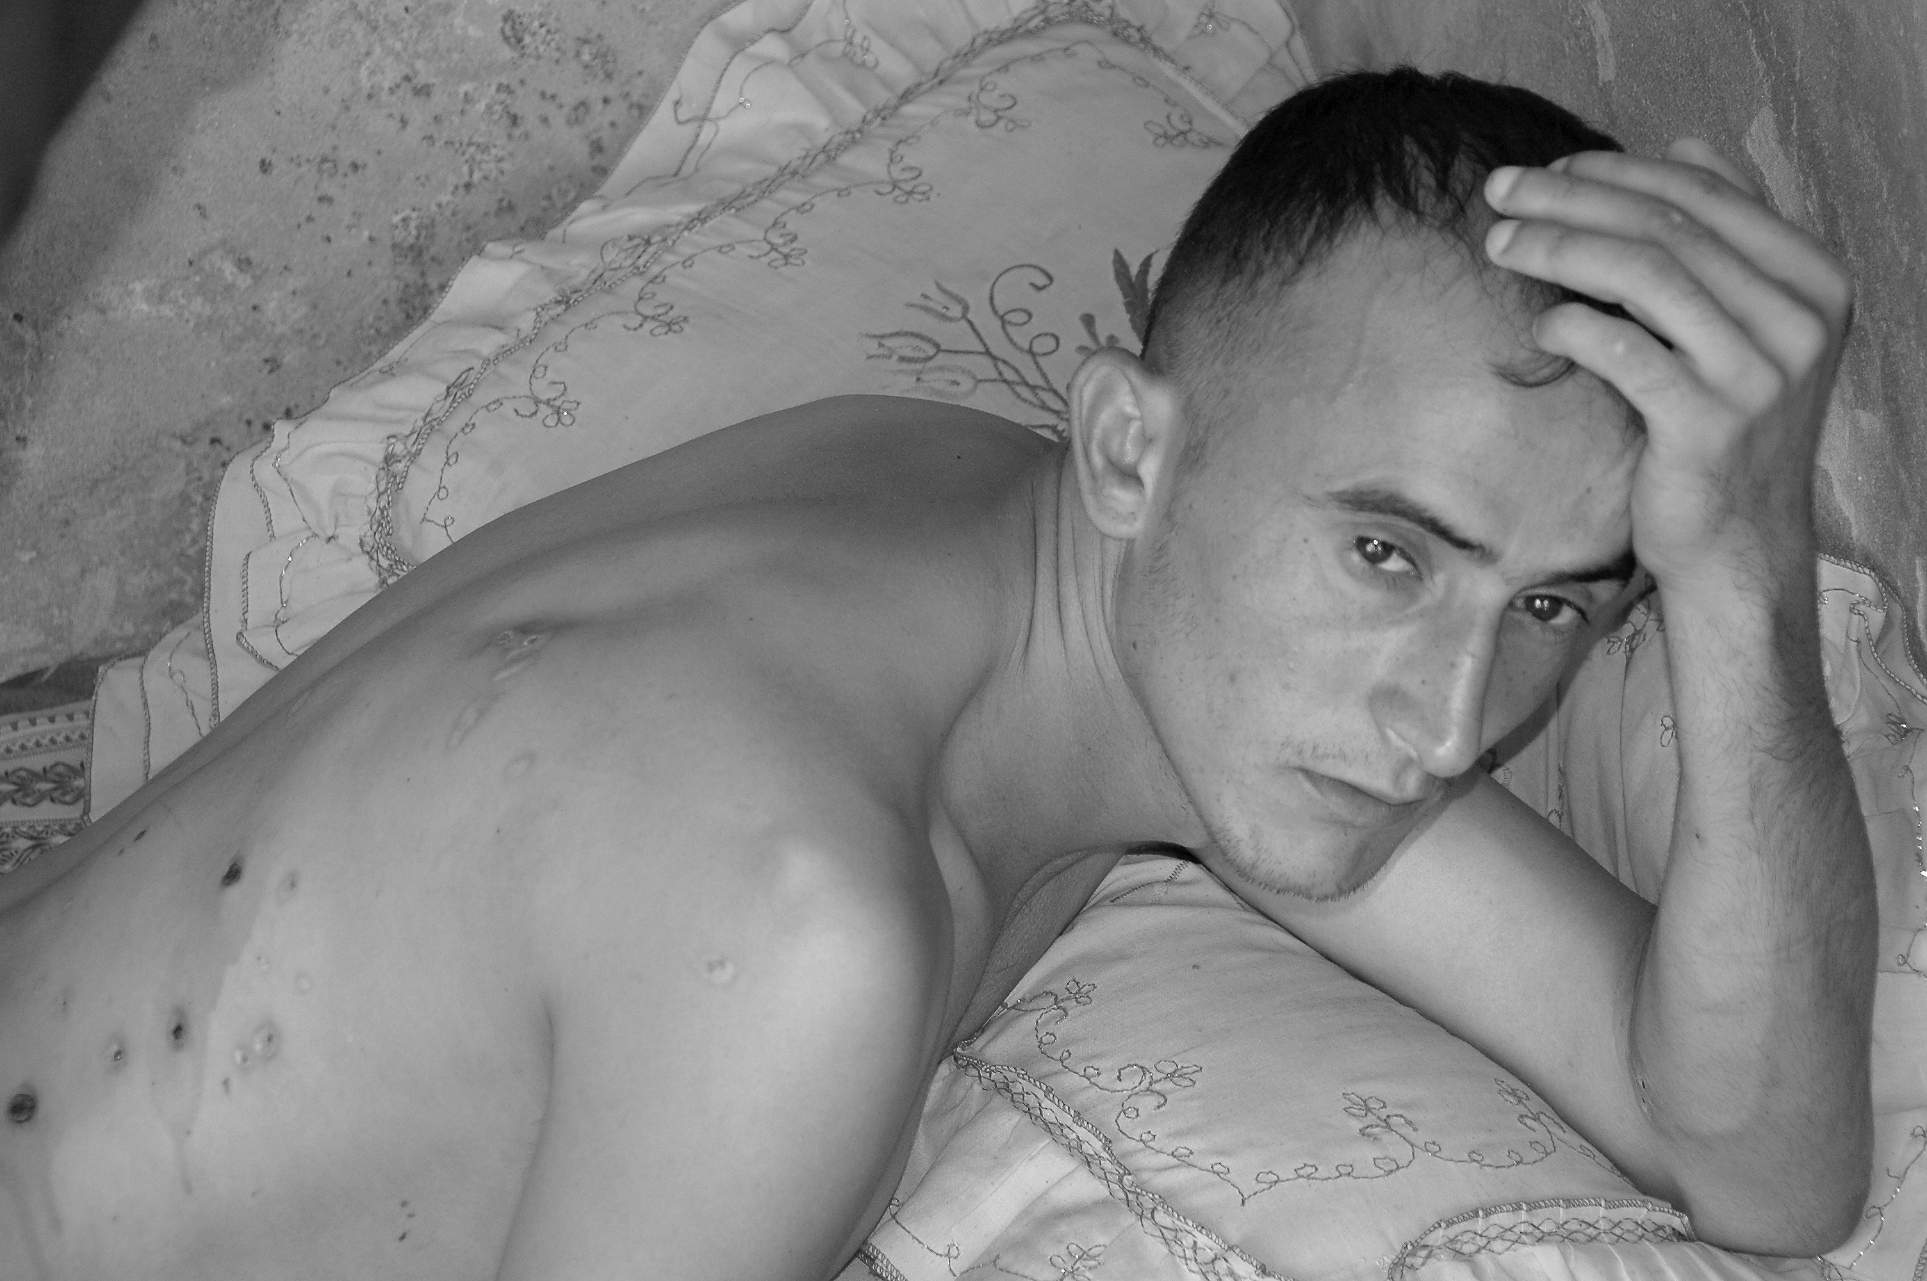
“Shock and Shrapnel”: Gazan treated for injuries at his home by a mobile medical team with the Palestinian Medical Relief Society after his house was shelled by Israeli tank fire during Operation Summer Rain. Photo by Gary Fields (2006)

Course Description
For the past 150 years, environments of conflict and violence, including war, have generated an enormous archive of visual imagery that has stirred enormous passion as well as debates and controversy. This course examines media and visual representations of violence, conflict, and war with a focus on visuality as components of history, culture and politics. Central to the course is the connection of “visuality” to violence, conflict and war through a variety of media, most notably photography, cinema, and photojournalism. This course seeks to engage with vexing questions related to the politics and culture of violence and its visual representation, such as: how do visual representations of violence inform and transform our understanding of it? What are the ethics of looking at, and sharing images of pain inflicted on others through various forms of communication technologies? How do media representations of conflict environments shape our understanding of world history and culture? Finally, the course seeks to find answers to whether visual representations as a form of media have altered public perceptions of conflicts and changed the trajectory of conflicts themselves.
* Syllabus subject to change.
Course Requirements
Participants are expected to attend all sessions in this course and complete the readings for each week. Absences will be noted and affect your final grade. The work product for this course will likely consist of biweekly reflection papers of 1-2 pages on the assigned reading material / videos for the week. These will be due on the Thursday of each week. Ideally, these reflections should focus on one or more themes for the week and should examine arguments, debates, and controversies raised in the readings. Even more importantly, these reflections should raise questions that emerge from the assigned material. Students will also be broken into groups corresponding to weeks 2-9 for presentations to the rest of the class on one of the weekly themes. Grades will be based on a combination of the weekly reflection papers, the presentation, and overall class participation.

Weekly Themes

Week 1 Prelude: A Vocabulary for the Visual Culture of Conflict, Violence and War

Reinhardt, Mark (2018). Violence. Visual Global Politics. Roland Blieker, ed. London: Routledge. [pp. 321-27]. Read online edition from UCSD Library Website. https://www.taylorfrancis.com/books/edit/10.4324/9781315856506/visual-global-politics-roland-bleiker

Hutchison, Emma (2018). Trauma. Visual Global Politics. Roland Blieker, ed. London: Routledge. [Read pp. 310-313].

Der Derian, James (2018). War. Visual Global Politics. Roland Blieker, ed. London: Routeledge.

Moeller, Susan D. (2018). Compassion Fatigue. Visual Global Politics. Roland Blieker, ed. London: Routeledge. [pp. 75-80]

Week 2 Visuality: Controversies over Images of Violence and War

Linfield, Susie (2010). The Cruel Radiance: Photography and Political Violence. Chicago: University of Chicago Press. [pp. 5-11, 13-22, 33-62]. https://ebookcentral.proquest.com/lib/ucsd/detail.action?pq-origsite=primo&docID=616045

Judith Butler (2005). “Photography, War, Outrage,” PMLA, Vol. 120 (3), pp. 822-827. https://www.jstor.org/stable/25486216?seq=1

Mirzoeff, Nicholas (2011). “The Right To Look.” Critical Inquiry. Vol 37, Spring 2011, pp. 473-96. https://www.jstor.org/stable/10.1086/659354

Spence, Eloise (2022). “18 Images that Helped Define Modern Conflict.” AOAV.
18 images that helped define modern conflict - AOAV

Week 3 Slavery and its Legacy: Visualizing and Resisting the Terror of Racism in America
Turner, Christine (2021). Lynching Postcards: 'Token Of A Great Day'. [In-Class video]
Natividad, Ivan (2022). "Confronting America's Traumatic History of Lynching." Berkeley News. https://news.berkeley.edu/2022/06/16/confronting-americas-traumatic-history-of-lynching/
Raiford, Leigh (2011). Imprisoned in a Luminous Glare: Photography and the African-American Freedom Struggle. Chapel Hill: University of North Carolina Press. [Read pp. 1-9, 14-66 in Week 3 Module].
Robertson, Campbell (2018). “A Lynching Memorial is Opening: The Country has Never Seen Anything Like it.”
The New York Times. https://www.nytimes.com/2018/04/25/us/lynching-memorial-alabama.html

Stevenson, Bryan (2018). Video of Lynching Museum https://www.pbs.org/video/lynching-memorial-1524775412/

Equal Justice Initiative (2018). “The Legacy of Racial Injustice.” (5-minute video). https://museumandmemorial.eji.org/

Week 4 Media and Vietnam: Did Photo / Media Imagery Turn Opinions of War?

Hallin, Daniel (1986). The Uncensored War: The Media and Vietnam. Oxford: Oxford University Press.

Grifin, Michael (2010). “Media Images of War.” Media, War & Conflict. Vol. 3 (1): 7-41. [Read pp. 7-24].
https://journals.sagepub.com/doi/pdf/10.1177/1750635210356813

Rouquet, Camille (2019). “Shaping the Notion of Media Influence: The Remediated Images of the Vietnam
War.” HAL. https://hal.science/hal-03463791/

Week 5 Images Untaken: The Silence of Violence Against Women in War and Conflict

Azzoulay, Ariella (2018). “Rape. Visual Global Politics. Roland Blieker, ed. London: Routeledge. [pp. 237-43]. Read online edition from UCSD Library Website. https://www.taylorfrancis.com/books/edit/10.4324/9781315856506/visual-global-politics-roland-bleiker

Lamb, Christina (2021). Our Bodies, Their Battlefields: War Through the Lives of Women. New York: Scribner.

Berrman, Nina and Shackle, Samira (2021). “Visual Choices: Covering Sexual Violence in Conflict Zones.” Columbia University Dart Center for Journalism & Trauma.
https://dartcenter.org/resources/visual-choices-covering-sexual-violence-conflict-zones

Week 6 Torture: Abu Ghraib and the Perverse Aesthetics of Spectatorship
Linfield, Susie (2010). The Cruel Radiance: Photography and Political Violence. Chicago: University of Chicago Press. [pp. 151-71]

Mirzoeff, Nicholas (2006) “Invisible Empire: Visual Culture, Embodied Spectacle, and Abu Ghraib.” Radical History Review, Vol. 95 (spring), 21-44. https://www.jstor.org/stable/20715417

Adler, Amy (2016). “The Pleasures of Punishment: Complicity, Spectatorship and Abu Ghraib.” Punishment in Popular Culture. pp. 236-256. New York: New York University Press. https://www.jstor.org/stable/j.ctt1dxg7hd.11

Sontag, Susan (2004). “Regarding the Torture of Others.” New York Times. https://www.nytimes.com/2004/05/23/magazine/regarding-the-torture-of-others.html

Week 7 Weapon of the Weak: Cinematic Representations of Anti-Colonial Resistance / Terrorism
Norris, Jacob (2013). “The Battle of Algiers Transposed into a Palestinian Key.” Open Democracy.
https://www.opendemocracy.net/en/battle-of-algiers-transposed-into-palestinian-key/

Ponetecorvo, Gillo (1966). The Battle of Algiers. https://www.kanopy.com/en/ucsd/video/127213

Abu Assad, Hany (2005). Paradise Now. https://digitalcampus.swankmp.net/ucasandiego371665/play/62de36939fe83f74?referrer=marc

Week 8 War from Above: The Seen and Unseen Imagery of Warfare from the Sky

Kaplan, Caren (2018). Aerial Aftermaths: Wartime from Above. Durham: Duke University Press. [Selections]

Parks, Lisa and Kaplan, Caren (2017). Life in the Age of Drone Warfare. Durham: Duke University Press.
[pp. 1-21]. Read electronic version from UCSD Library Website.

Kaplan, Caren (2017). Dronorama: Troubling the Temporal and Spatial Logic of Distance Warfare. Life in the Age of Drone Warfare. Lisa Parks and Caren Caplan, eds. Durham: Duke University Press. [pp. 161-77]. Read electronic version from UCSD Library Website.

Week 9 Murals and Memory: Censoring ‘Offensive’ Visual Images

Wilson, Jennifer (2019). “Black People Don’t Need Murals To Remember Injustice.” The Nation.
https://www.thenation.com/article/archive/san-francisco-school-mural/

Kelly, Robin D.G.(2019). “We’re Getting These Murals All Wrong: The Arnautoff Mural have been denounced as demeaning and defended as an exposé of America’s racist past. Both sides miss the point.” The Nation.
https://www.thenation.com/article/archive/arnautoff-mural-life-washington/

Malik, Keenan (2023). “An Art Treasure Long Cherished is Deemed Offensive but by Whom? The Guardian.
https://www.theguardian.com/commentisfree/2023/jan/08/an-art-treasure-long-cherished-by-muslims-is-deemed-offensive-but-to-whom

Southerland, Jenna (2021). “Vermont Law School Is Right to Cover Over a Controversial Mural.” Hyperallergic.
https://hyperallergic.com/669286/vermont-law-school-is-right-to-cover-over-a-controversial-mural/

Freytas-Tamura, Kimiko (2021). “A School Mural Was Supposed to Celebrate Black Lives: Instead, It Was Destroyed.” New York Times. https://www.nytimes.com/2021/10/29/nyregion/brooklyn-school-mural-diversity.html

Dickenson, Michael and Smithers, Gregory (2021). “The Power of Empty Pedestals.” The Bitter Southerner.
https://bittersoutherner.com/2020/the-power-of-empty-pedestals

Week 10 The Camera as Witness? Visual Imagery in Resisting Oppression and Violence

Stein, Rebecca L. (2021). Screen Shots: State Violence on Camera in Israel / Palestine. Stanford: Stanford University Press.

Stein, Rebecca L. (2021). Interview in Jadliyya. https://www.jadaliyya.com/Details/43402

